

SIMATS ENGINEERING

Saveetha Institute of Medical and Technical Sciences
Chennai- 602105

Student Name:B.Lakshmi Lohitha Reg. No.:192324182
Course Code: CSA16 Slot: C
Course Name: Data Warehousing & Data Mining
Course Faculty: Dr. D. Beulah David
Project Title: Educational Learning Analytics using Data Warehouse, Text Mining, Decision Tree, K-Means Clustering, KNIME, WEKA and Microsoft Power BI
Module Photographs:
Module Photo  Module 4- Business Intelligence & Dashboard | Individual student contribution module work in the project | Presentation Image
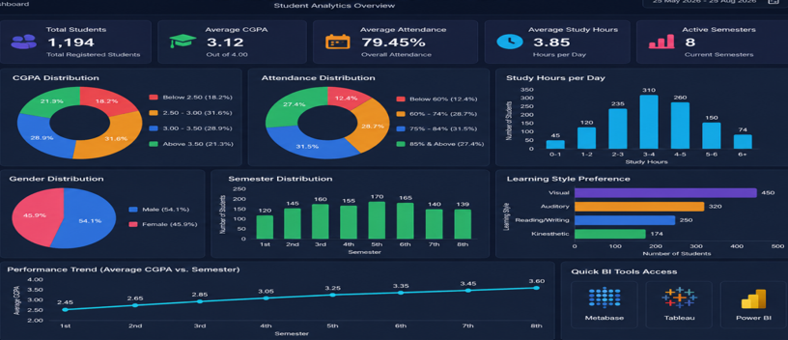 | 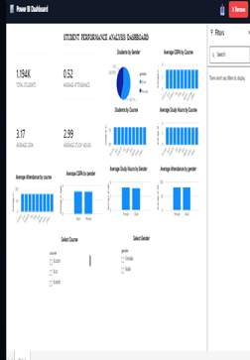 | 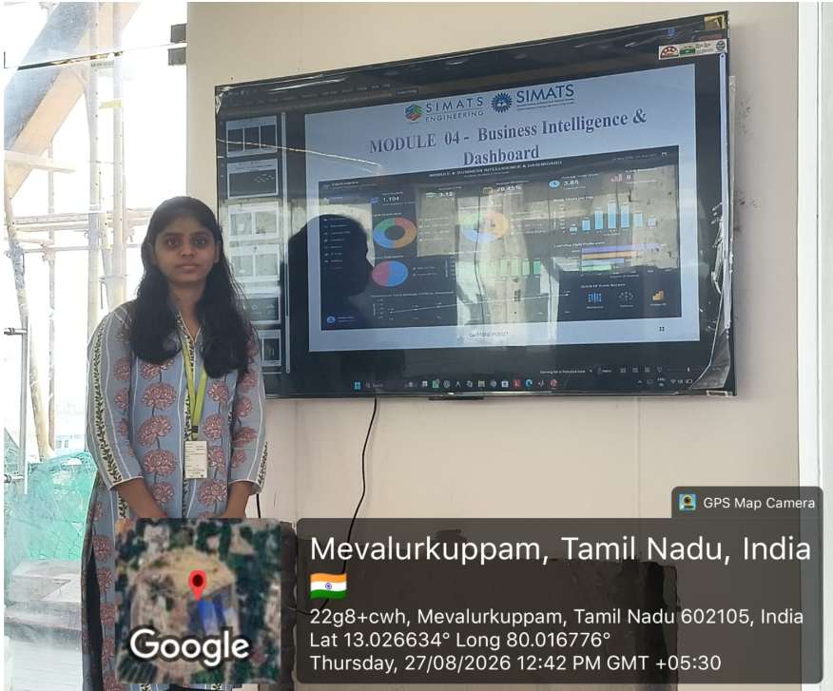
Project Description: Module 4- Business Intelligence & Dashboard

The project “Educational Learning Analytics using Data Warehouse, Text Mining, Decision Tree, K-Means Clustering, KNIME, WEKA and Microsoft Power BI” focuses on analysing educational data to understand student performance and learning patterns. Data Warehouse and Text Mining techniques organize and extract useful information, while Decision Tree and K-Means Clustering identify performance patterns and learner groups. KNIME and WEKA support data processing and analysis, and Microsoft Power BI creates an interactive dashboard displaying performance, attendance, learning trends, and analytical results. The dashboard helps educators compare student performance and recognize areas that require improvement. It also presents complex analytical results in a simple and understandable visual format. Overall, the project provides a data-driven approach to educational analysis and academic decision-making.
W

Student Signature Guide Signature

